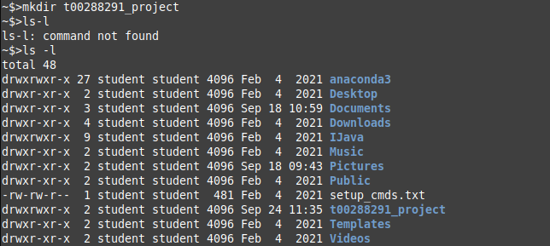
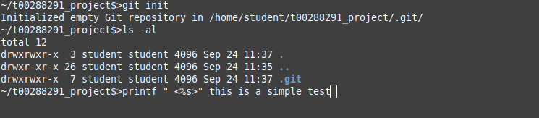
The “mkdir” command makes a subdirectory and the “ls” command displays the contents of the subdirectory in the “long format”. Here I can see the time for when the directory was created. The “git init” command initialises a directory as a git repository

“ls -al” will show hidden files in directory. .git is an example of this. Normally you will not see the .git directory as it is hidden. “cd ~” goes to home directory
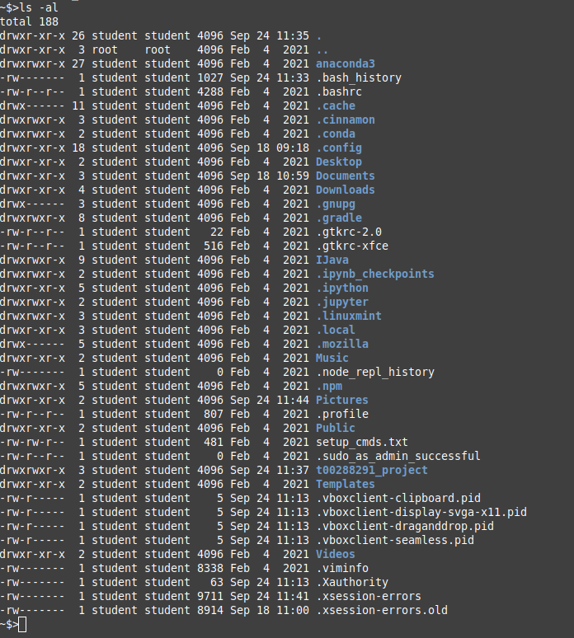
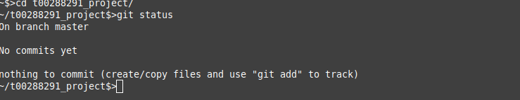
line “ls -al” showes all the files I’m in my cmd and I didn’t type in a git unit and it got me an error as expected

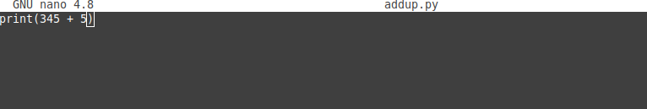
by using command “nano addup.py” you are opening some cmd project in which if you type “print ( 4 + 5 ) it will show you that in the terminal
by pressing CTRL X it quits the nano file

By typing cat (name of file) it shows what were in that file

by typing python (addup.py) it showes how many symbols are there
by cheking “git status” it shows you and asks you about your details
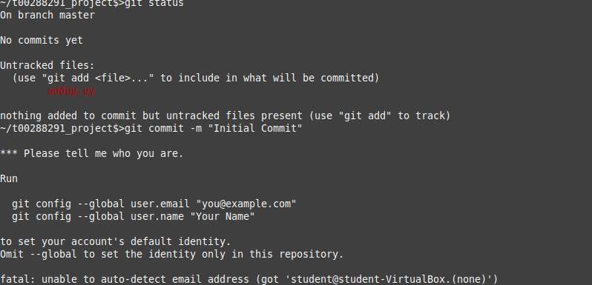
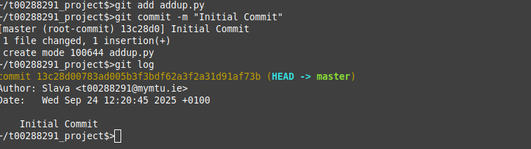
to add your detail type in “git config --global user.name “name” ” you can tell it your name, and by typing “git config --global user.email” you can share your email with the program check every time with the teacher if anything goes wrong` Type in “nano (name of the file)” to make changes in it
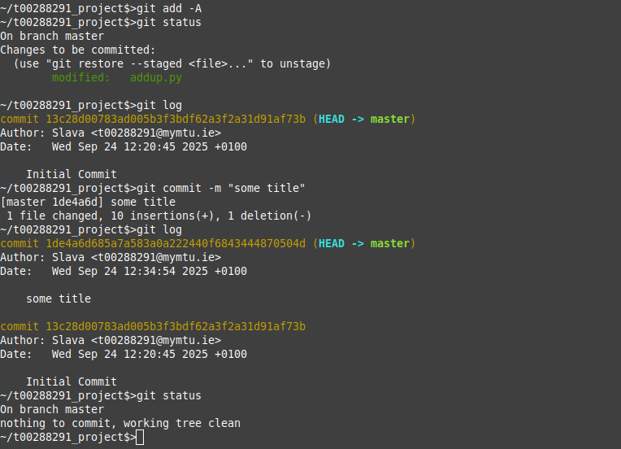
by typing “cat (name of the file)” you can see what changes have been made by typung “git add -a” it saves changes and be typing “git status” you can check how is it going) “git log” shows you the fille changes by typing “ git commit -m “some title” you can name what chagne you have done like adding the comment and check the changes after by “git status”

